Perimeter and Area-Answers
Key Stage 3: 2003 Paper 1 Level 5-7
1.
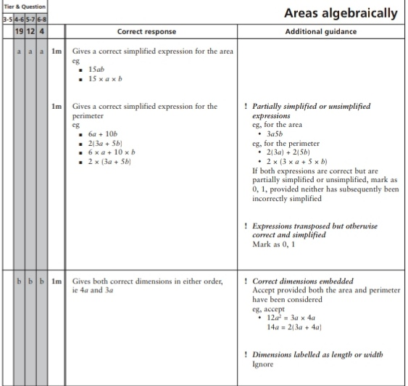
Key Stage 3: 2003 Paper 2 Level 5-7
2.
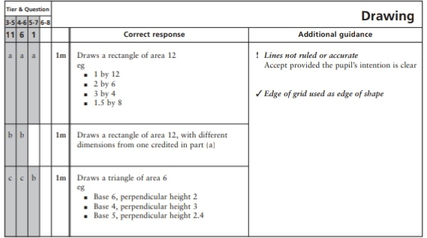
3.
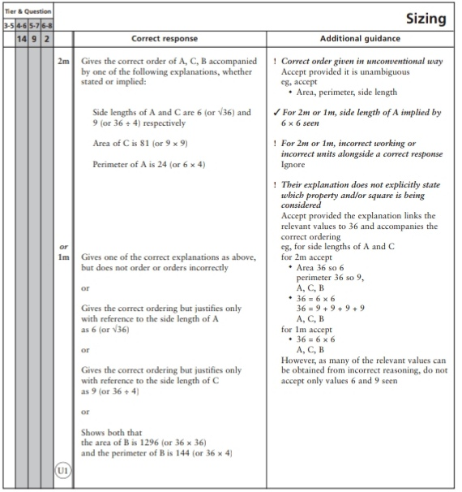
4.
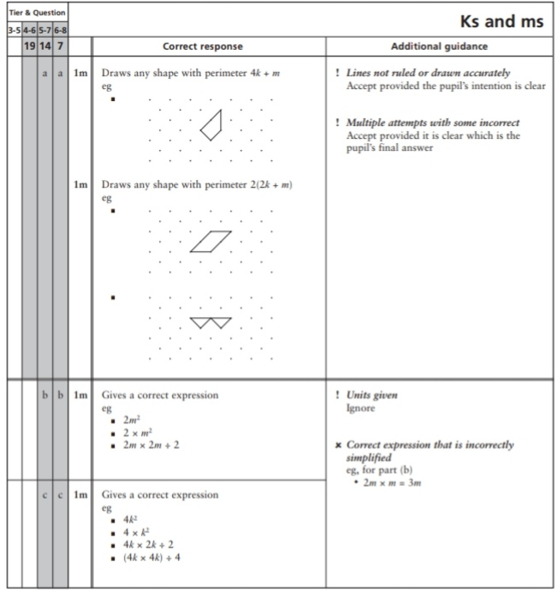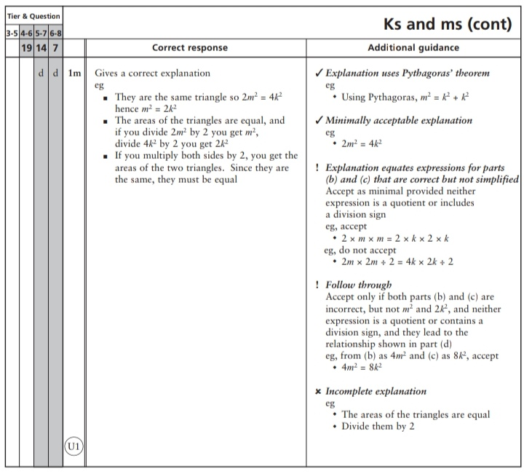
Key Stage 3: 2003 Paper 1 Level 6-8
5.
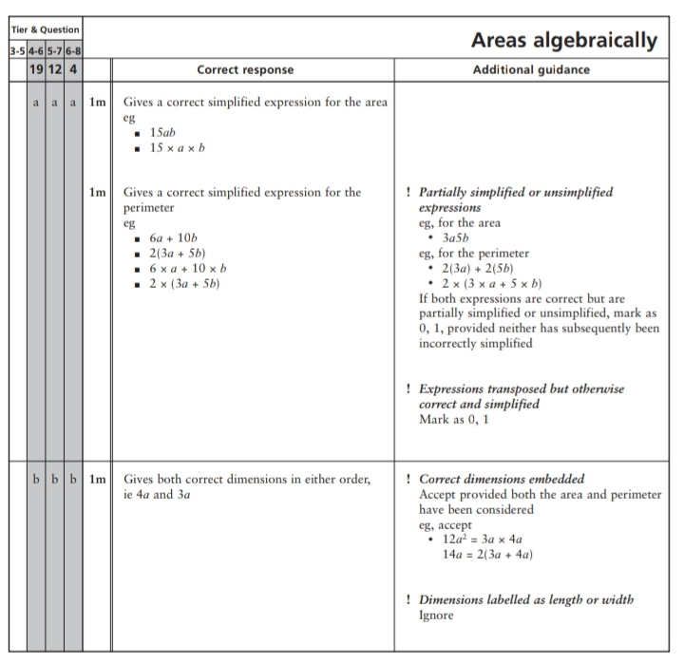
Key Stage 3: 2003 Paper 2 Level 6-8
6.
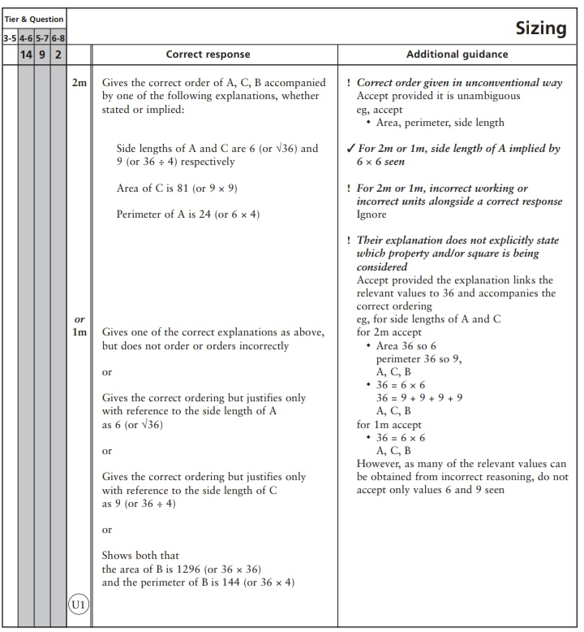
7.
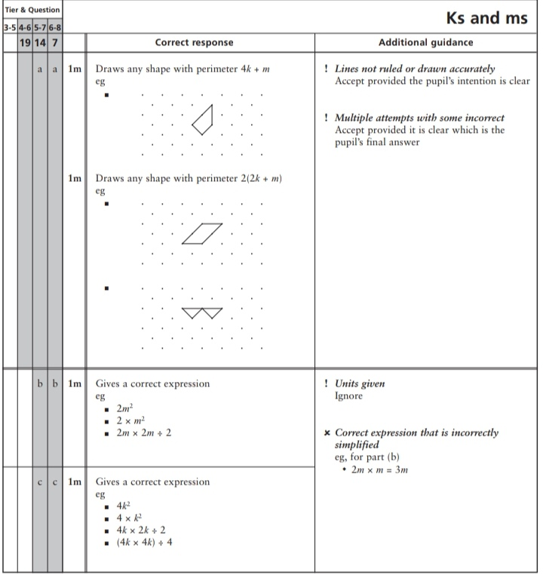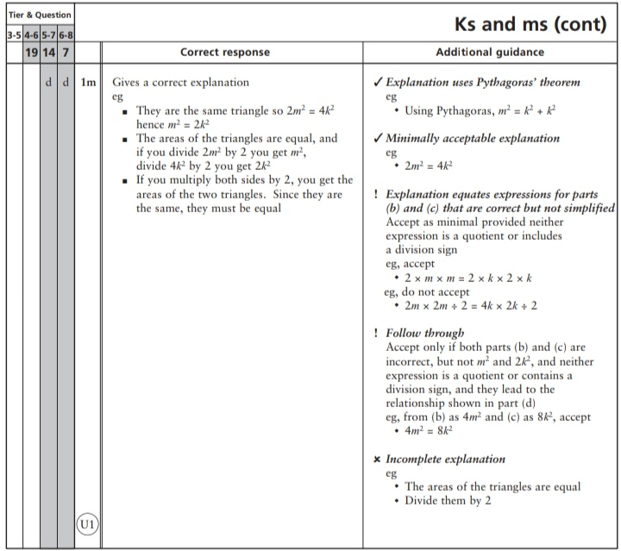
Key Stage 3: 2004 Paper 1 Level 5-7
8.
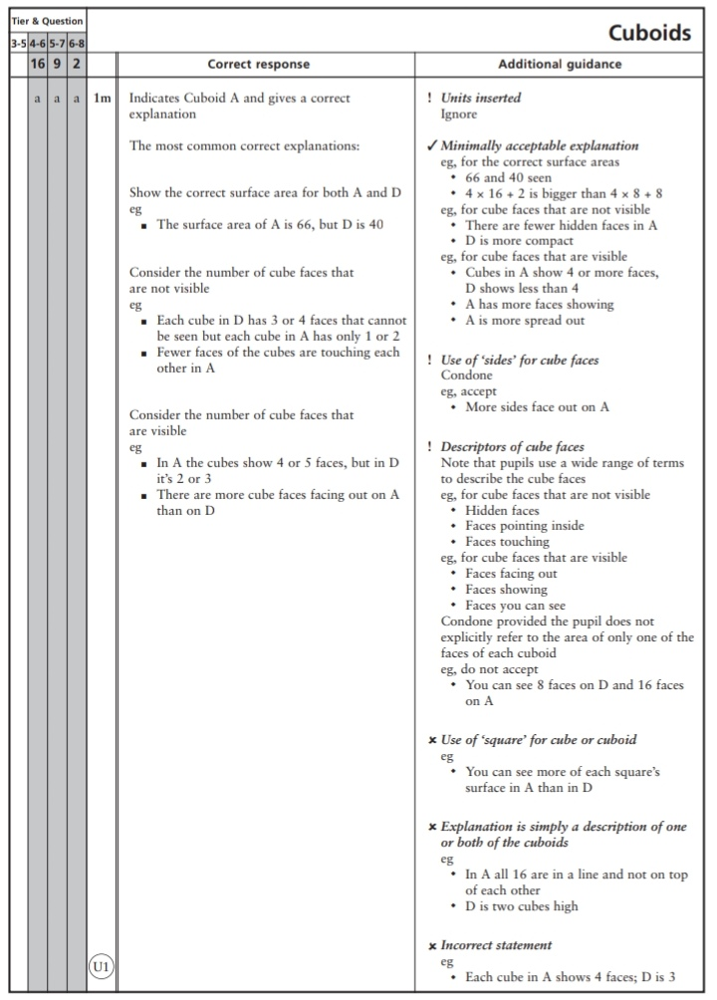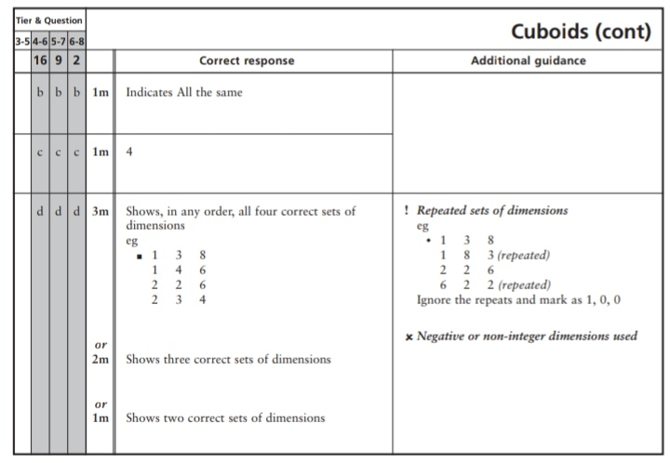
Key Stage 3: 2004 Paper 1 Level 6-8
9.
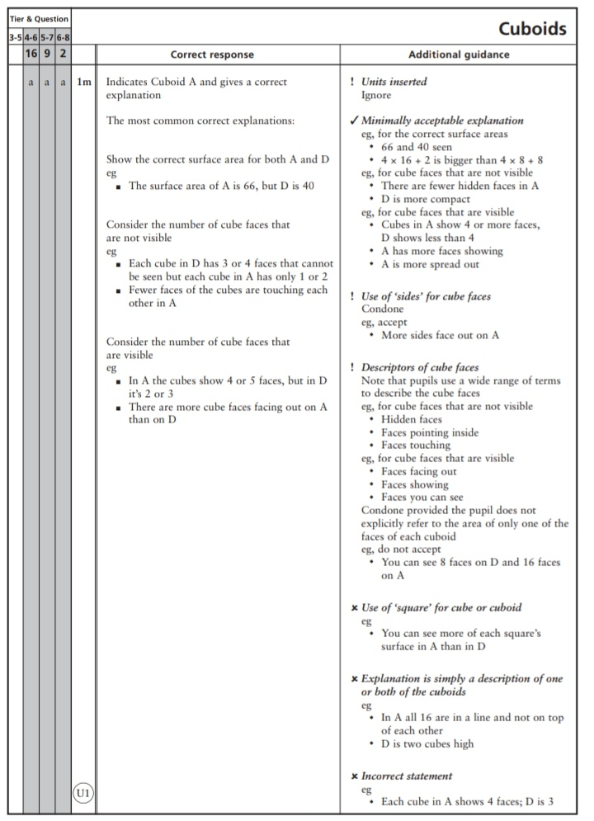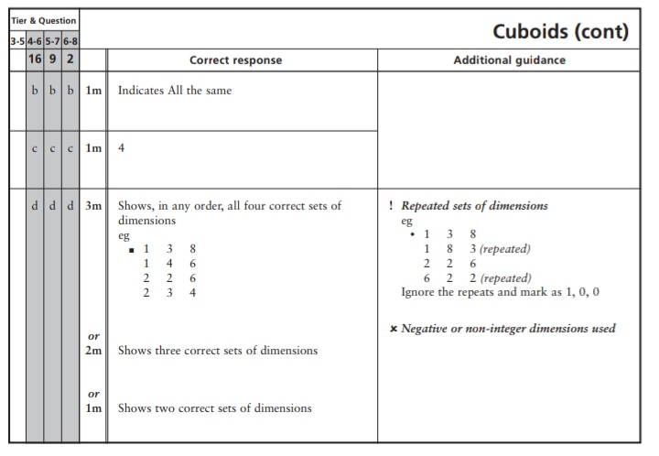
Key Stage 3: 2004 Paper 2 Level 6-8
10.
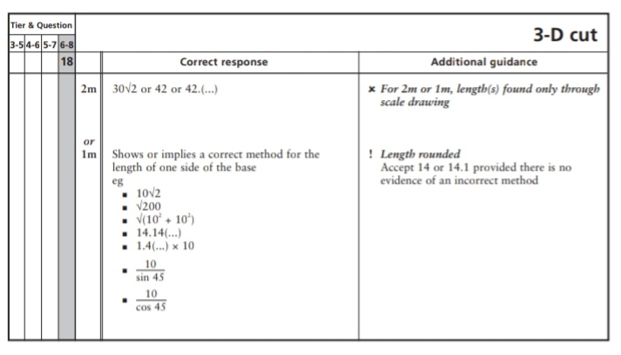
Key Stage 3: 2005 Paper 1 Level 5-7
11.
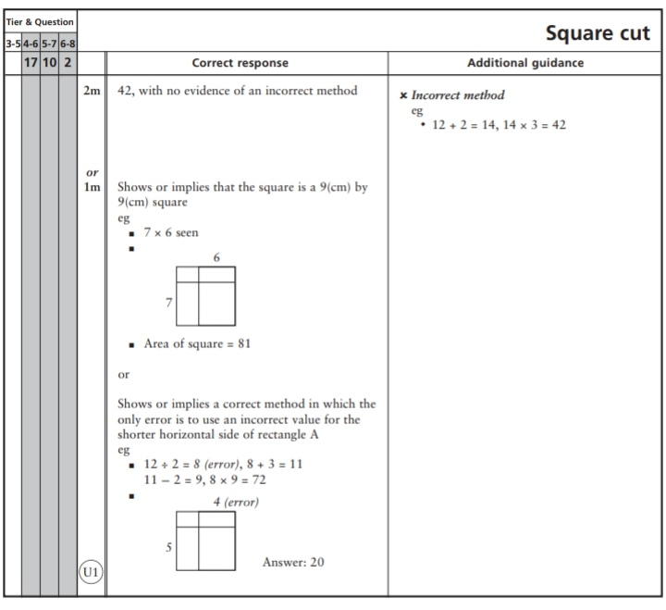
Key Stage 3: 2005 Paper 2 Level 5-7
12.
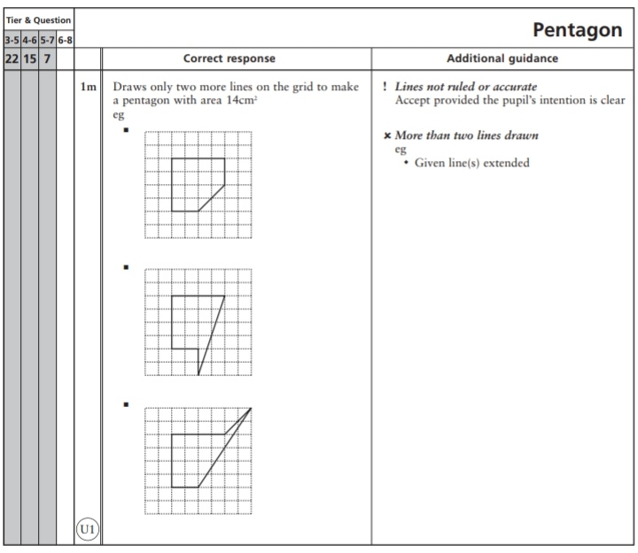
Key Stage 3: 2005 Paper 1 Level 6-8
13.
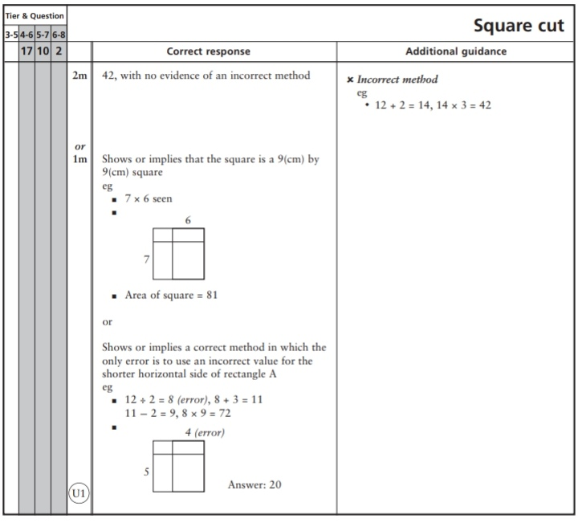
Key Stage 3: 2006 Paper 1 Level 5-7
14.
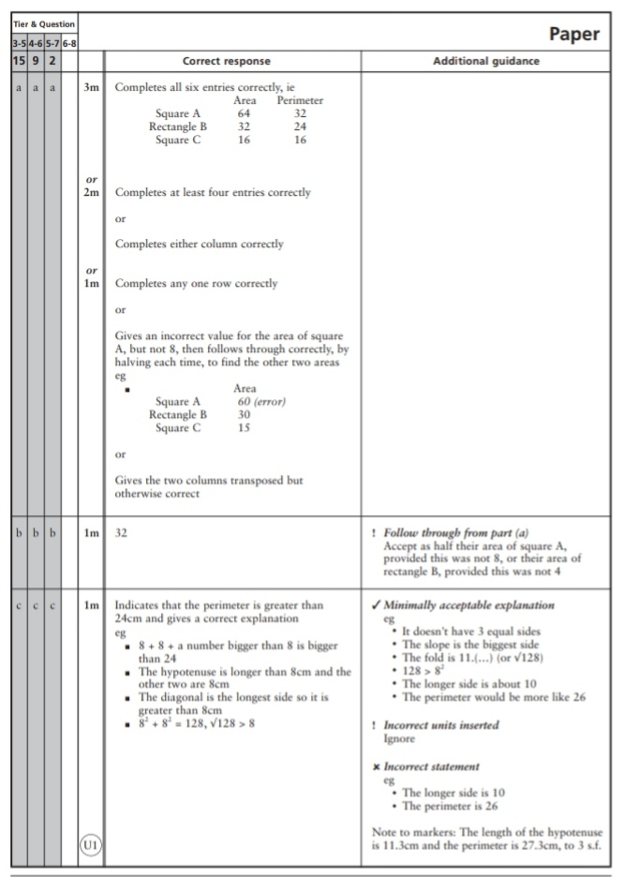
Key Stage 3: 2007 Paper 2 Level 5-7
15.
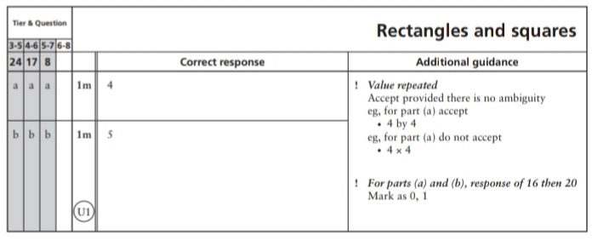
16.
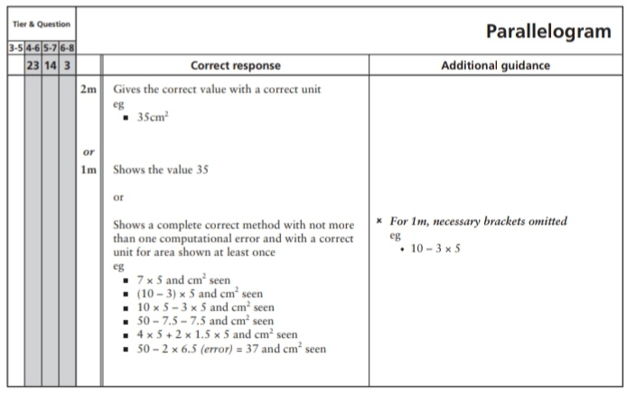
Key Stage 3: 2007 Paper 1 Level 6-8
17.
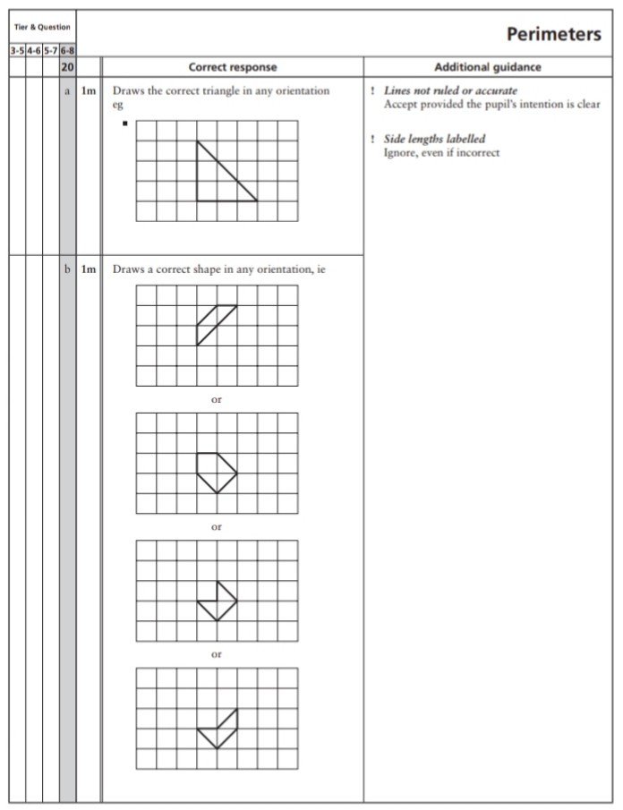
Key Stage 3: 2007 Paper 2 Level 6-8
18.
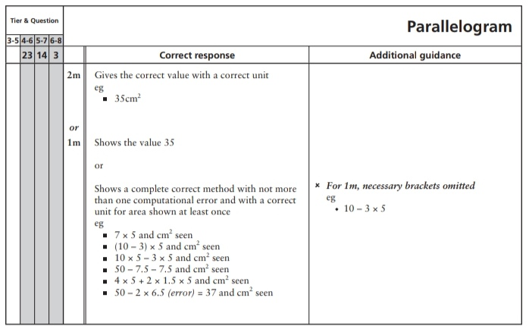
Key Stage 3: 2008 Paper 1 Level 5-7
19.
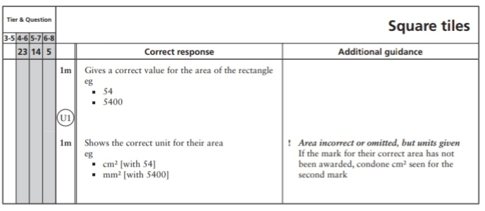
Key Stage 3: 2008 Paper 2 Level 5-7
20.
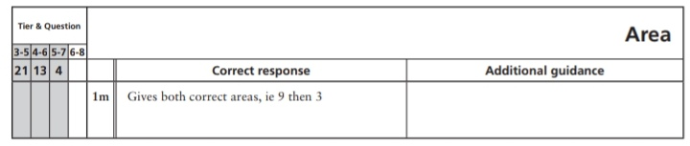
21.
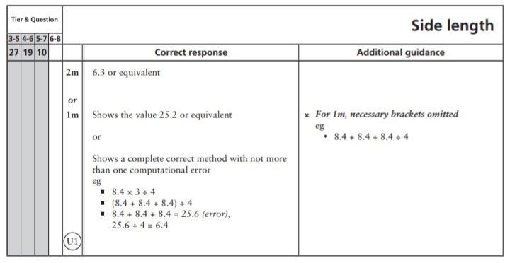
22.
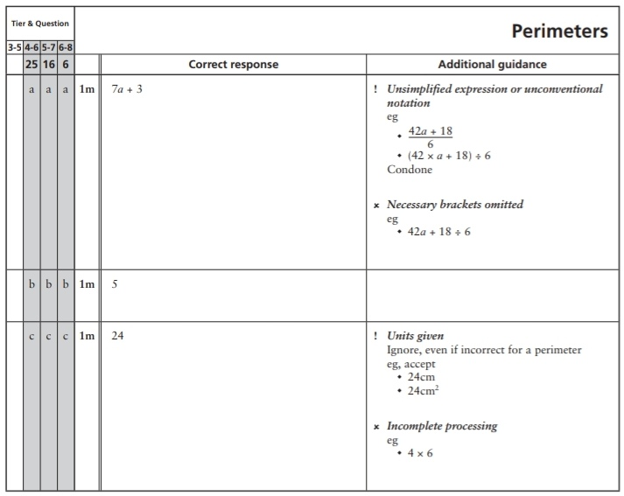
Key Stage 3: 2008 Paper 1 Level 6-8
23.
24.
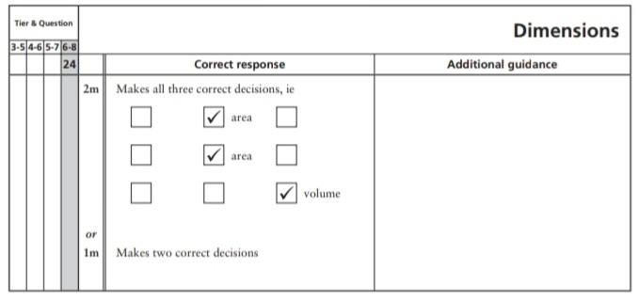
Key Stage 3: 2008 Paper 2 Level 6-8
25.
Key Stage 3: 2009 Paper 1 Level 5-7
26.
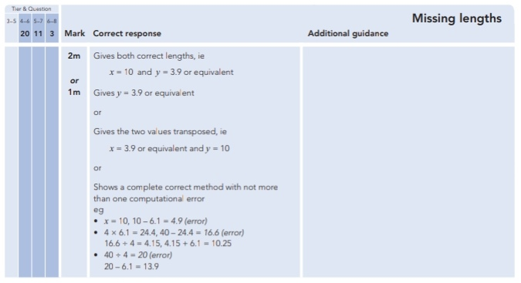
27.
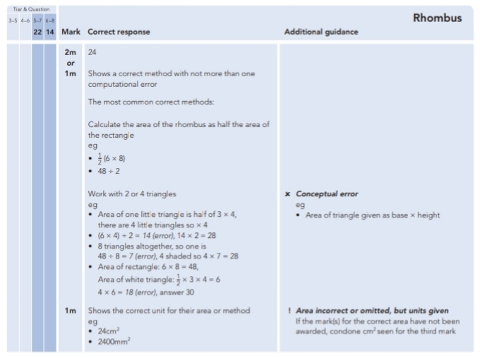
28.
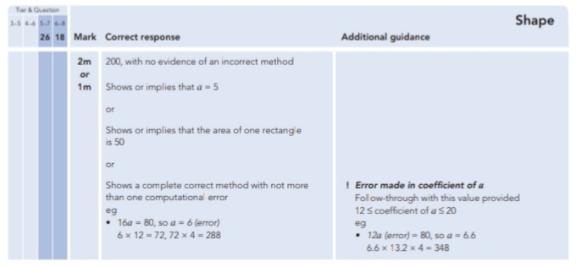
29.
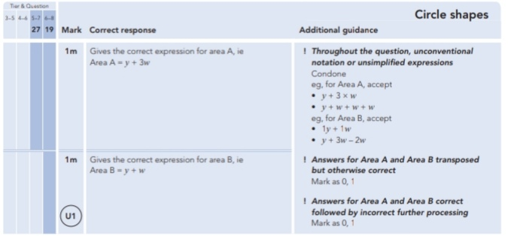
Key Stage 3: 2009 Paper 2 Level 5-7
30.
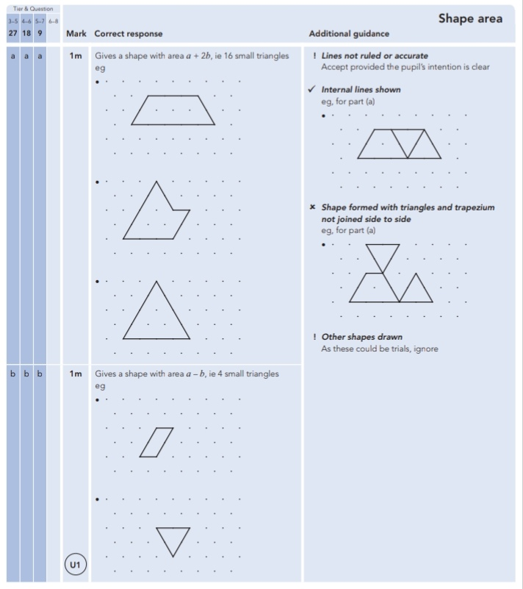
31.
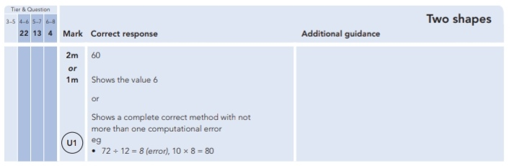
Key Stage 3: 2009 Paper 1 Level 6-8
32.
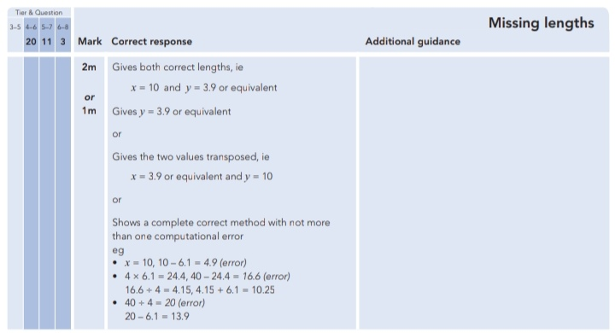
33.
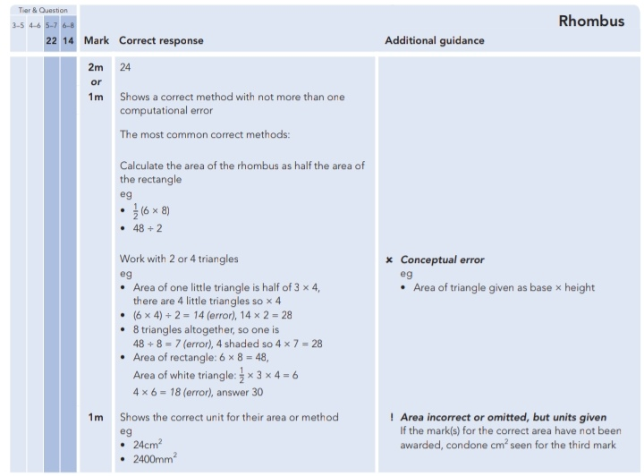
34.
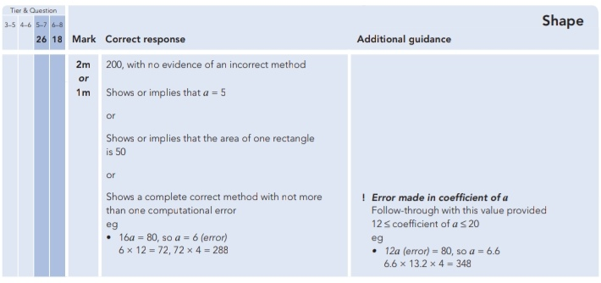
35.
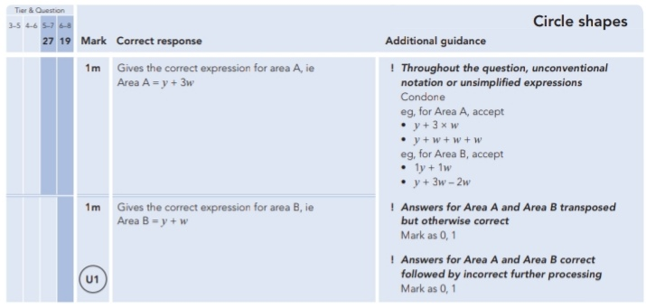
Key Stage 3: 2009 Paper 2 Level 6-8
36.
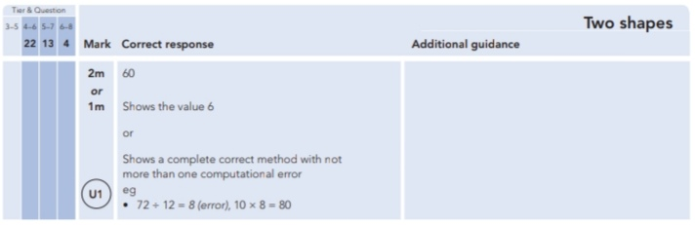
Key Stage 3: 2010 Paper 1 Level 5-7
37.
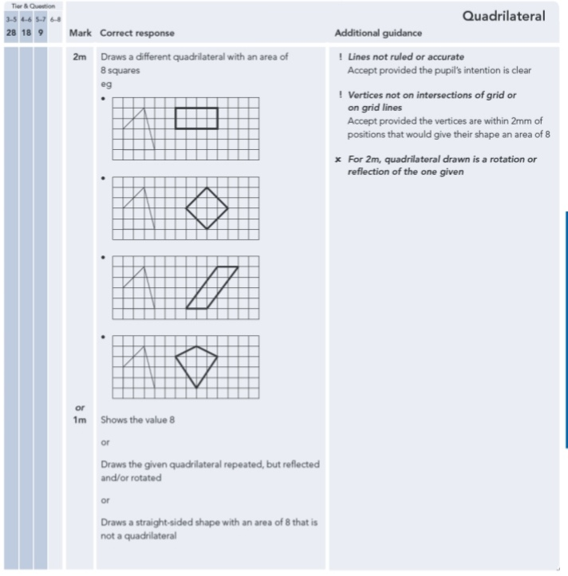
Key Stage 3: 2010 Paper 2 Level 5-7
38.
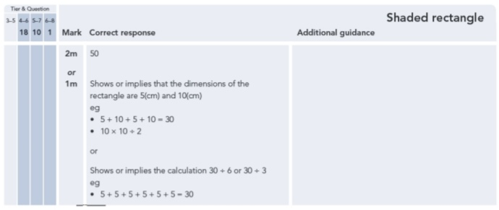
39.
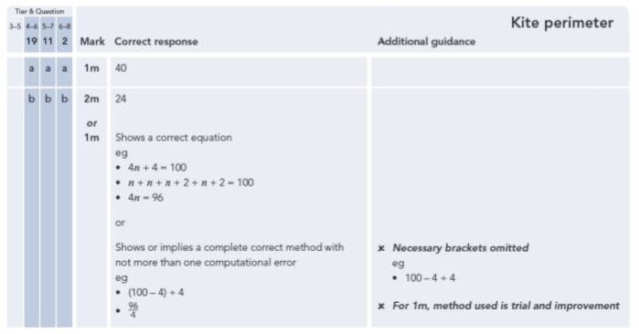
Key Stage 3: 2010 Paper 2 Level 6-8
40.
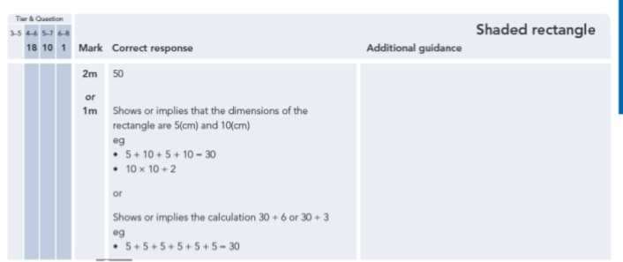
41.
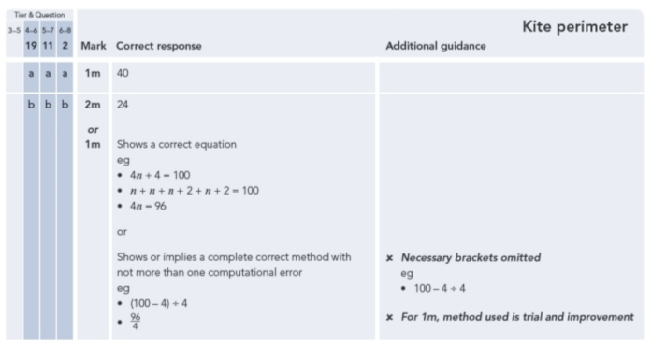
Key Stage 3: 2011 Paper 1 Level 5-7
42.
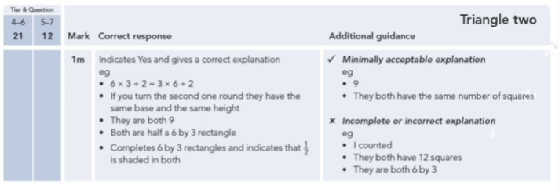
43.
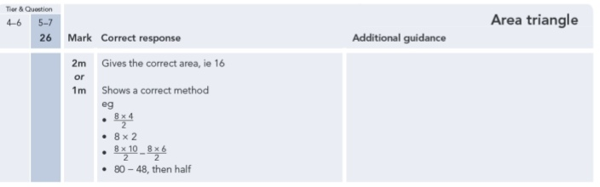
Key Stage 3: 2011 Paper 2 Level 5-7
44.
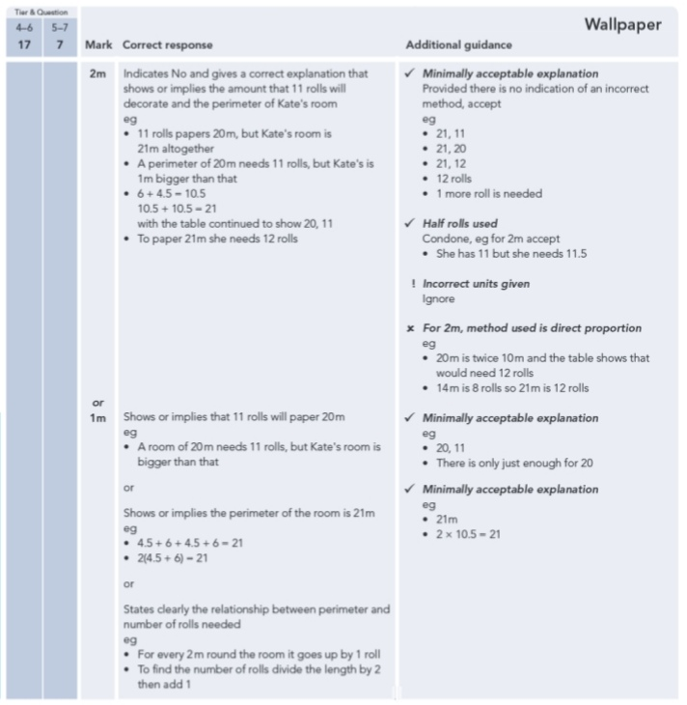
45.
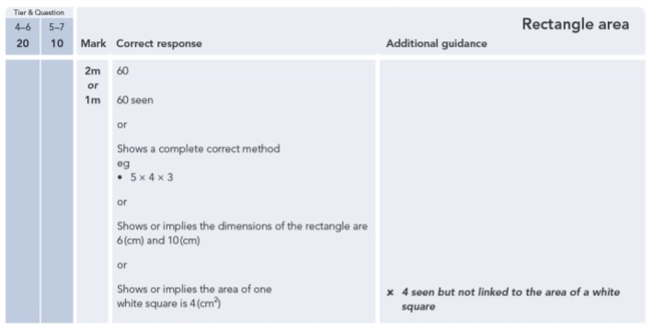
46.
